Dynamic UI Generation Guide

**Version 3.3**

PSL Team

11/29/2011

Contents

Purpose 3

Introduction 3

Details 4

Examples 8

1) Tune Receiver 8

2) Chart Recorder 11

3) Spectral Line Display 20

4) Pulsar Display 26

# Purpose

This document contains the details about how to generate UI dynamically just by modifying few xml files. It illustrates an example each wherever dynamic UI has been generated in CMS application.

# Introduction

For generating a UI dynamically we basically need 2 files

1. The template xml file which contains the UI elements. In most cases only this file needs to be changed to add new control on UI.

Following is the list of templates present in CMS for various screens

1. Receiver setup files
   * continuum.xsl
   * spectral-line.xml
   * pulsar.xml
   * planetary.xml
   * sun-moon.xml
2. ChartRecorder.xml – Template xml to generate the UI for chart recorder.
3. servoTrendPlot.xml – Template xml to generate the UI for the trend plot
4. SpectralLineDisplay.xml – Template xml to generate the UI for the spectral plot
5. PulsarDisplay.xml – Template xml to generate the UI for the pulsar plot
6. The xsl file which is used to transform template xml into HTML format. This file will not need any change most of the time. Server restart is needed for change in this file to reflect.

Following is the list of xsl files already used in CMS to generate UI

1. htmlgenerator.xsl – xsl used to generate Tune Receiver UI
2. ChartRecorder.xml – xsl used to process ChartRecorder.xml file and generate UI for chart recorder.
3. servoTrendPlot.xml – xsl used to process ChartRecorder.xml file and generate UI for trend Plot preferences
4. SpectralLineDisplay.xsl – xsl used to process SpectralLineDisplay.xml file and generate UI for Spectral Line Display preferences
5. PulsarDisplay.xsl – – xsl used to process PulsarDisplay.xml file and generate UI for Pulsar Display preferences

# Details

Let us start explaining the generation of dynamic UI with the help of an example.

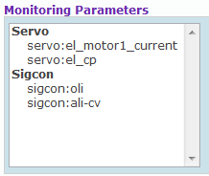

Figure 1

The figure shown above contains a select box. For generating this UI dynamically we have to make a template xml file of the UI elements and an xsl file which will transform the template xml file into the HTML format.

The template xml for the above UI will look like this:

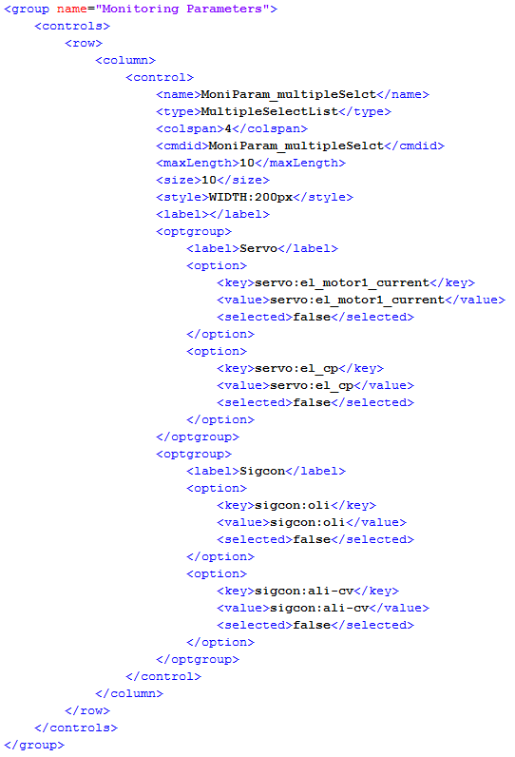

Figure 2

Let us start explaining each node one by one.

1. Groups – It contains the list of groups present under a section. The attribute available with node is ‘templateName’ where user can mention the name of the template. It’s useful in some cases however; it’s not used as of now.
2. Group – It groups various HTML elements to form a section, so to add a new group related to new subsystem, one need to add a new group section to template xml. The supported attribute is on this node is “name”.
3. Controls – One section can contain various HTML controls. The list of these controls is provided in this. It contains 4 attributes i.e. type, cssClass, sectionname, rowspan.
4. Row - Represents a line on GUI, if user need to add a new control on new line then this tag should be added. This is synonymous <TR> element in HTML.
5. Column - Represents a cell on UI, this acts as a container of actual UI elements (e.g. Textbox, radio button etc.). This is synonymous <TD> element in HTML.
6. Control - Represents actual UI element on the screen, user can configure various properties for control depending upon the type of control chosen, following are various configurable properties of this element.
   1. Disabled - Used to disable a control on UI, so that by default user can’t change default values for a preconfigured template.
   2. type -  Used to configure type of element to be added on UI, following are various values
      1. radio              –     adds a radio button control on UI
      2. checkbox     –     adds a checkbox element on UI
      3. Text               –     adds a textbox element on UI
      4. Dropdown  –     adds a dropdown element on UI
      5. MultipleSelectList –adds a multiple select dropdown element on UI
   3. name –   Actual name of the control corresponding to element on UI.
   4. cmdid –  This is same as “name” field mentioned and is kept their for future use (if needed), however, this might be removed in future
   5. label    –  Used to specify the label of the UI element (e.g. – APERTURE)
   6. value   –  Used to specify default value for UI element.
   7. subsystemName – Used to specify the name of the subsystem associated with element
   8. options – For controls which have range of valid values (e.g. position values) we use dropdown control. For such controls we use Dropdown on UI. This property is used to configure various values.
   9. checked – Used to specify whether checkbox element on UI should be checked by default
   10. maxLength – It is used to specify the maximum number of characters allowed in that UI element.
   11. onClick – This property is used for buttons. It contains the name of the javascript function which is to be called on click of that button.
   12. onChange – This property is used for dropdowns. It contains the name of the method which is to be called on change of the dropdown option.
   13. Tooltip – It contains the data to be shown in the tooltip.
   14. Style – It is used to specify the style, such as height, width, background color, alignment, etc.
   15. Size – it is used to specify the number of the parameter shown in multiple select box without scroll, if a value is 5 than at-least 5 elements displayed.

So in the above UI all the controls fall under the section named ‘Monitoring Parameters’. Here the controls are arranged in 2 rows. The first row contains the control of type dropdown and the second row contains 2 controls of type button arranged in 2 columns.

# Examples

Following are few examples about how to configure the UI at various places in CMS.

## Tune Receiver

Following is the command configuration section for receiver setup for SIGCON system before adding a new parameter.

We will add a configuration parameter named “NEW”, which has 2 channels.

Note that NEW here is used to just indicate a new command/configuration parameter name, but it can be any command name like move, track etc.

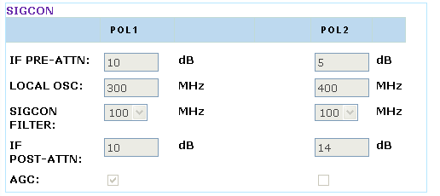

Figure 3

Let’s add following lines in continuum.xml at the end of sigcon section.

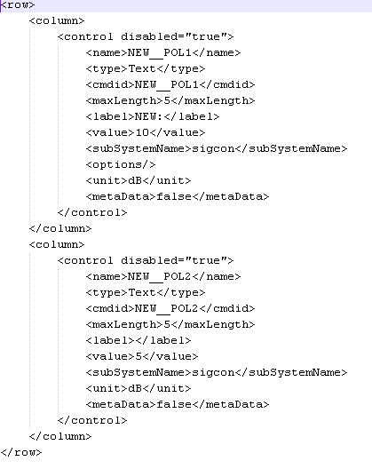

Figure 4

Please notice the contents of “name” tag above, it has following format X__Y,

X here represents the command name, whereas Y indicates the parameter name. Both of these should be separated by ‘__’ (double underscore). If a command has multiple parameters then one can just repeat entries of X__Y1, X__Y2 and so on in xml file under “column/control” nodes.

Following is effect of adding these lines on tune receiver UI.

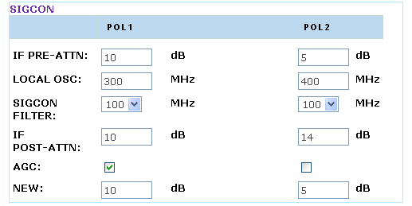

Figure 5

In order to execute this newly added command we also need to add new command in sigcon_commands.xml –

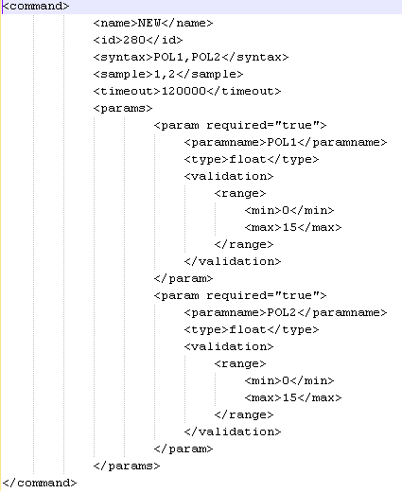

Figure 6

## Chart Recorder

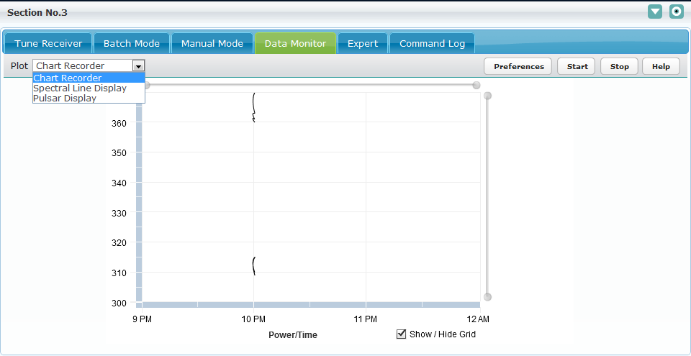

Figure 7

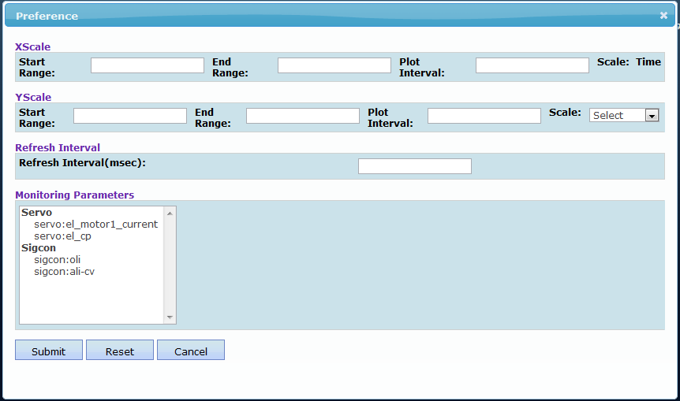

Figure 8

The chart recorder Preference screen shot is dynamically generated. The files which are used for generating chart recorder Preference dynamically is ChartRecorder.xml (template xml file) and ChartRecorder.xsl (xsl file).

User can add a new section similar to that of Monitoring Parameters or filter just by changing the template xml file. Steps for adding a new section named ‘New Monitoring Parameters’ are as follows.

1. Copy the complete ‘controls’ node of Monitoring Parameters from ChartRecoder.xml file shown in Figure 2.
2. Paste it just below the closing tag of ‘controls’ node of ‘MoniParam_multipleSelect’ as shown in Figure 9.

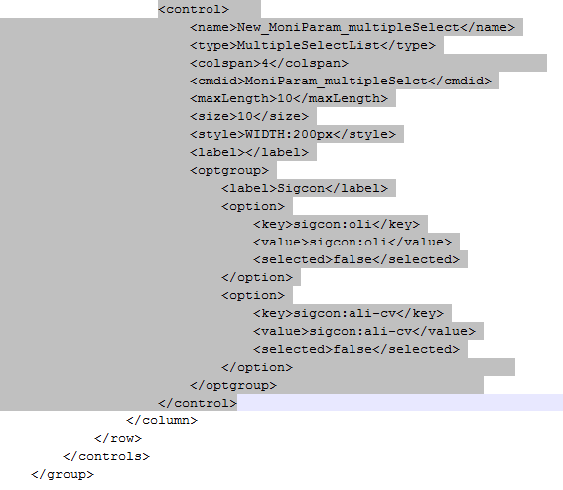

Figure 9

1. Populate various values for newly added “New_MoniParam_multipleSelect”, we need to add corresponding entry in ChartRecoder.xml file as well. For this just copy existing “<control>” node of ‘MoniParam_multipleSelect’ and change few attributes highlighted below in figure 10. Following are the nodes to be modified
   1. <Name> – Set name as any name like New_MoniParam_multipleSelect
   2. <Size> - At a time how many parameters you want to display without scroll bar.
   3. <Style> - Here user can set the width, height, background color etc.
   4. <optgroup> - This very important section which contains multiple <options> where you can specify the monitoring parameters, here configuring two monitoring parameters, sigcon:oli, sigcon:ali-cv.

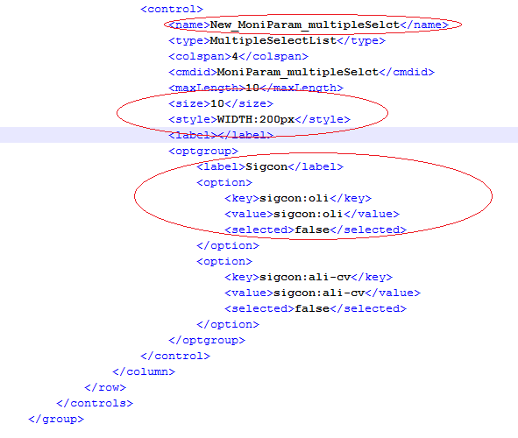Figure 10

1. With above changes ui looks like,

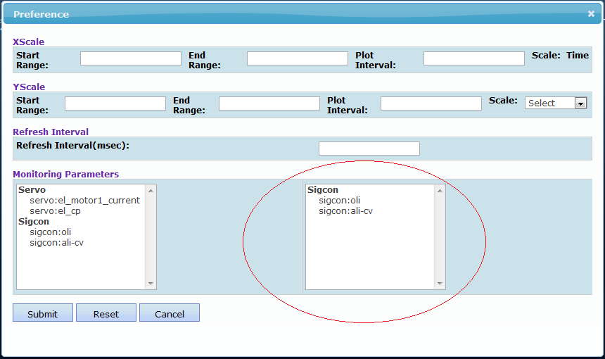

Figure 11

1. Now Add new label and Text box into existing UI
2. Open ChartRecoder.xml now look into refresh interval section as show in below

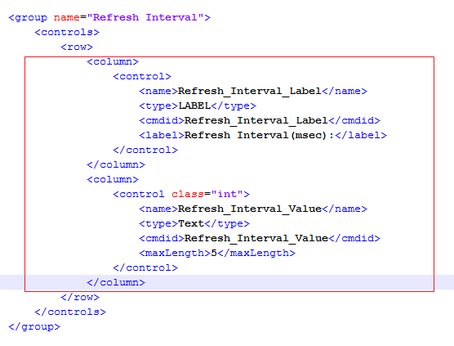

Figure 12

* 1. Copy above both <control> and pest it below it look like,

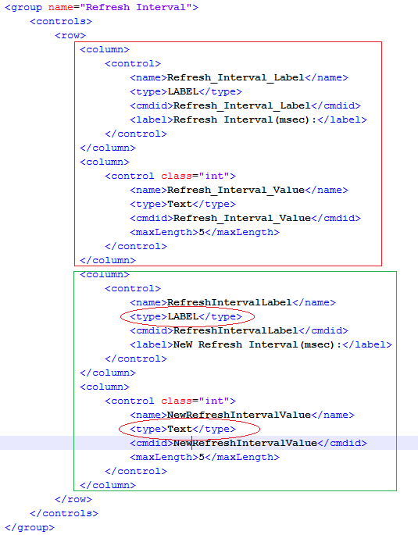

Figure 13

* 1. Now notice the first <control> type is LABEL and second control type is Text, change the attributes <name> and <cmdid> attributes.
  2. Now update UI looks like as below,

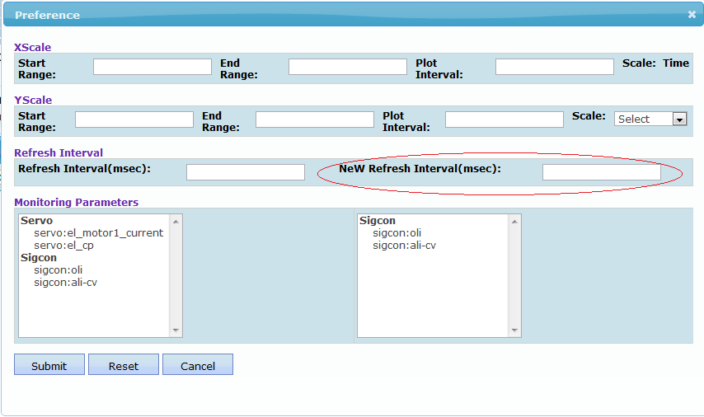

Figure 14

***Note & Assumptions:***

* Existing ChartRecoder.xml contains 4 section as below,
  + XScale –
    - All the values Start Range, End Rand, Plot Interval, Scale name must be start with Xscale_
    - If dynamically add any component than please start <name> <cmdid> values must be start with Xscale_
    - <name> and <cmdid> nodes values are used in java script and other java implementation so don’t change these value if user is changing these node values than need to modify the code according.
  + YScale –
    - All the values Start Range, End Rand, Plot Interval, Scale name must be start with Yscale_
    - If dynamically add any component than please start <name> <cmdid> values must be start with Yscale_
    - <name> and <cmdid> nodes values are used in java script and other java implementation so don’t change these value if user is changing these node values than need to modify the code according.
  + Monitoring Parameters –
    - If dynamically add any component than please start <name> <cmdid> values must be start with MoniParam_

## Spectral Line Display

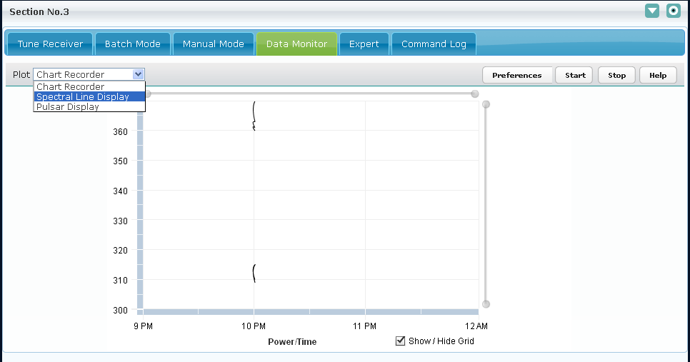

Figure 15

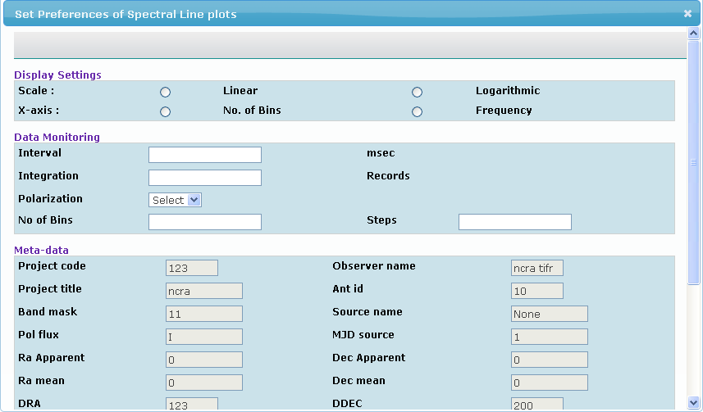

Figure 16

The spectral line display Preference screen shot is dynamically generated. The files which are used for generating chart recorder Preference dynamically is SpectralLineDisplay.xml (template xml file) and SpectralLineDisplay.xsl (xsl file).

User can add new parameters by adding the controls in template xml and making the entry for the same parameter in backend-commands.xml.

1. Steps to add a control say radio button name “**new_scale**” with values say “**new_linear**” and ”**new_logarithmic**” in “Display Settings” section of template.xml.

Example:

User wants to add two radio controls.

Following conventions must be followed while setting the attributes of radio button.

1. **<type>:** Type will be “**radio**”
2. **<name>** : Name of all radio buttons in a single radio group must be same. In this example we have added two new radio buttons. Name of radio button must start with “**sendspectralplottingdata__**” followed by its name.

Example : sendspectralplottingdata__new_scale

1. **<cmdid>:** Cmdid of the control must start with “**sendspectralplottingdata __”** followed by its name.

Example : sendspectralplottingdata__Linear

1. **<label> :** Label can be any valid name.

Example : New Linear

1. **<value>:** Value will be the one which user needs to send to backend system when that particular radio button will be selected.

Example : new_linear

1. **<checked>:** true/false depending upon user wants the radio button to be by default checked/unchecked.

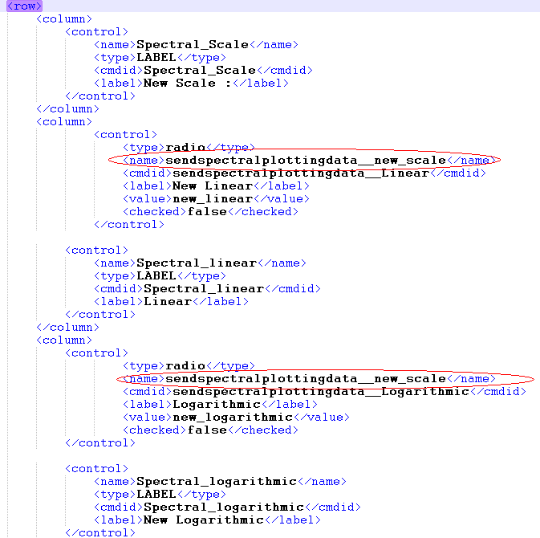

Figure 17

1. User also needs to make entry of the added radio control in “**backend_commands.xml**” in “**sendspectralplottingdata**” command in following way.

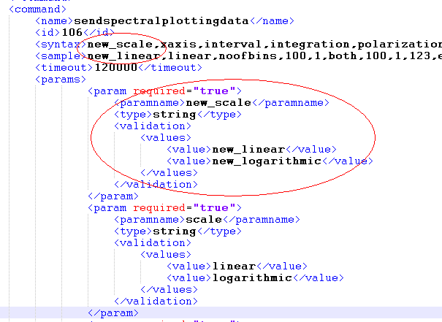

Figure 18

* 1. **<syntax>** : When the radio control was added ,its name was “**sendspectralplottingdata__new_scale**” (refer above).

Here the name of the parameter will be only “**new_scale**” i.e. “sendspectralplottingdata__” must be removed and the parameter must be added in the syntax.

* 1. **<param>:** Add a param tag with values as mentioned in “value” of radio buttons.

In this case they will be “new_linear” and “new_logarithmic”.

* 1. **<sample>:** Add one of the values as sample value.

In this case it will be “new_linear”.

User will be able to see the new radio control added on the preferences dialog of Spectral line display.

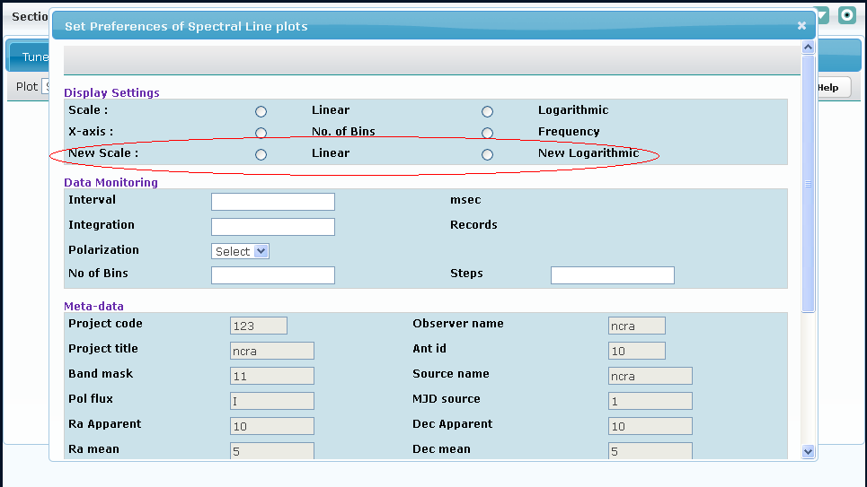

Figure 19

***Note & Assumptions:***

* Existing SpectralLineDisplay.xml contains 3 sections Display Settings, Data Monitoring and Meta data section.
* Names of all the input fields must start with “**sendspectralplottingdata__**”
* <name> and <cmdid> nodes values are used in java script and other java implementation so don’t change these value .If user is changing these node values than need to modify the code according.
* Meta-data section fields are all read-only and they correspond to Global parameter” bean data.

User can change this data through “Expert ” or “Tune Receiver”

## Pulsar Display

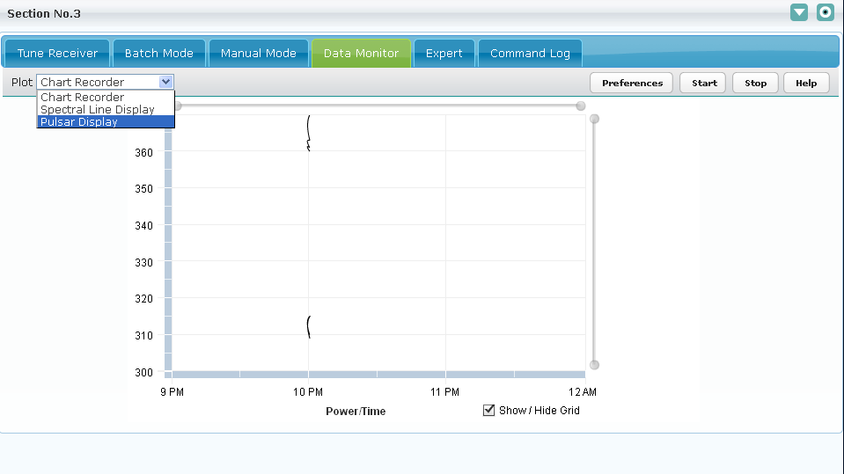

Figure 20

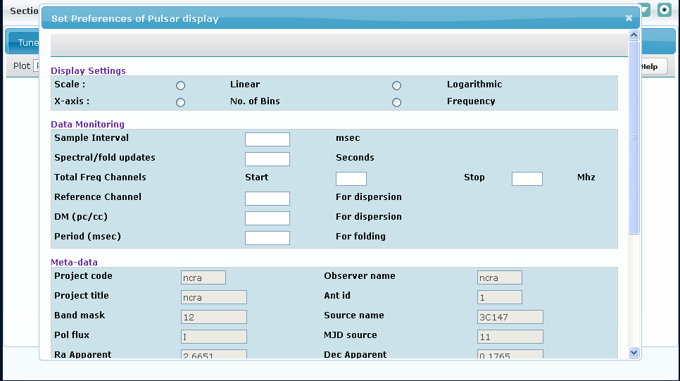

Figure 21

The pulsar display Preferences dialog is dynamically generated. The files which are used for generating chart recorder Preference dynamically is PulsarDisplay.xml (template xml file) and PulsarDisplay.xsl (xsl file).

User can add new parameters by adding the controls in template xml and making the entry for the same parameter in backend-commands.xml.

* + - 1. Steps to add a control say drop down name “**sample**” with dropdown values say “**sample1**”

and ”**sample2** in “Display Settings” section of template.xml .

Example:

Following conventions must be followed while setting the attributes of dropdown.

1. **<type> :** Type will be “**Dropdown**”
2. **<name>** : Name of the control must start with “**sendpulsarplottingdata__”** followed by its name.

Example : sendpulsarplottingdata__sample

1. **<cmdid>** : Cmdid of the control must start with “**sendpulsarplottingdata__”** followed by its name.

Example : sendpulsarplottingdata__sample

1. **<colspan>** : If required colspan can be specified for that particular column

Example: <colspan>2</colspan>

1. **<options>** : Specifies the options that will be shown in the dropdown.
2. **<option>** : User needs to specify the key and value for each option in option tag.
3. **<key>** : Key is the one that is displayed to user on the dropdown.
4. **<value>** : Value is the one that is sent to backend after a particular option in dropdown is selected.

Example : <options>

<option>

<key>sample1</key>

<value>sample1</value>

</option>

</options>

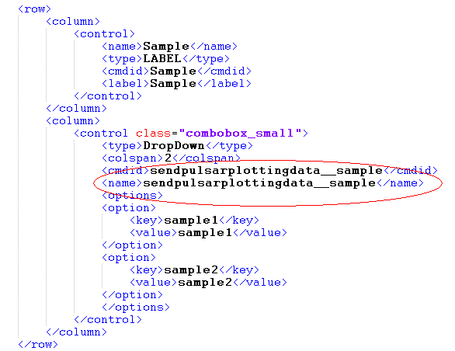

Figure 22

1. User also needs to make entry of the added dropdown control in “**backend_commands.xml**” in “**sendpulsarplottingdata**” command in following way.
2. **<syntax>** : When the dropdown control was added ,its name was “**sendpulsarplottingdata __sample**” (refer above).

Here the name of the parameter will be only “**sample**” i.e. “sendpulsarplottingdata__” must be removed and the parameter must be added in the syntax.

1. **<param>:** Add a param tag with values as mentioned in “value” of dropdown options.

In this case they will be “sample1” and “sample2”.

1. **<sample>:** Add one of the values as sample value. In this case it will be “sample1”.

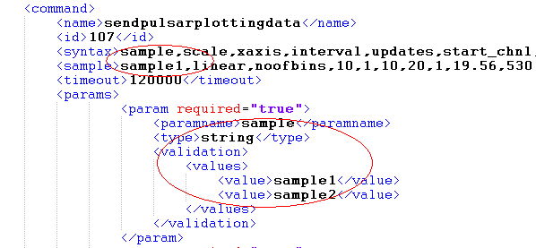

Figure 23

User will be able to see the new dropdown control added on the preferences dialog of Pulsar display.

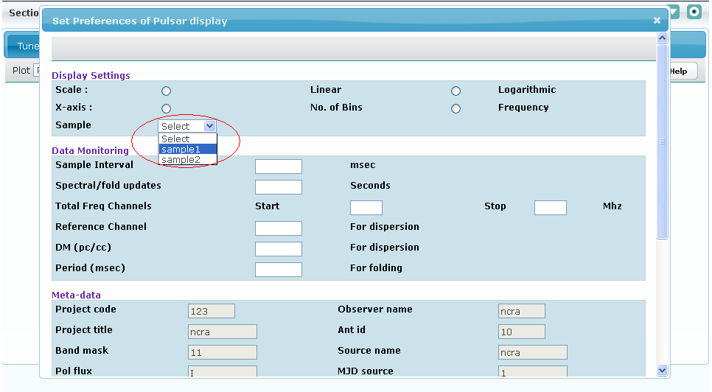

Figure 24

***Note & Assumptions:***

* Existing Pulsar.xml contains 3 sections Display Settings, Data Monitoring and Meta data section.
* Names of all the input fields must start with “**sendpulsarplottingdata __**”.
* <name> and <cmdid> nodes values are used in java script and other java implementation so don’t change these value .If user is changing these node values than need to modify the code according.
* Meta-data section fields are all read-only and they correspond to Global parameter” bean data.

User can change this data through “Expert” or “Tune Receiver”